**Most important:** This band relies heavily on tracks. The Killers have 9 people on stage and we have 4/5 so these tracks are in place to fill (no pun intended) out the sound to replicate the Killers Live show. (Let it be noted that the Killers also use tracks) These need to be out front **and prominent**

**The band requires at least a 30-minute change over period. Anything less and it can affect the set duration**

|  |  |
| --- | --- |
| Channel | Instrument |
| 1 | Kick |
| 2 | Snare |
| 3 | Rack tom |
| 4 | Floor Tom 1 |
| 5 | Floor Tom 2 |
| 6 | Hi Hat |
| 9 | OH1 |
| 10 | OH2 |
| 11 | Playback - Track – (DI Supplied) |
| 12 | Playback - Click Track -(DI Supplied) |
| 13 | Bass DI |
| 14 | Front Keys Top (Microkorg) DI L |
| 15 | Front Keys Top (Microkorg) DI R |
| 16 | Front keys Bottom (NordLead2) DI L |
| 17 | Front keys Bottom (NordLead2) DI R |
| 18 | Guitar Amp (Fender) |
| 19 | Vocal Mic (Primary vocals straight stand round base with LONG cable) |
| 20 | Vocal Mic (Over front keys - Wireless) |
| 21 | Vocal Mic (bassist) |
| 22 | Vocal Mic (Guitarist) |
| 23 | Vocal (Extra Guitarist) |
| 24 | Acoustic DI |
| 25 | Electric DI or Amp |

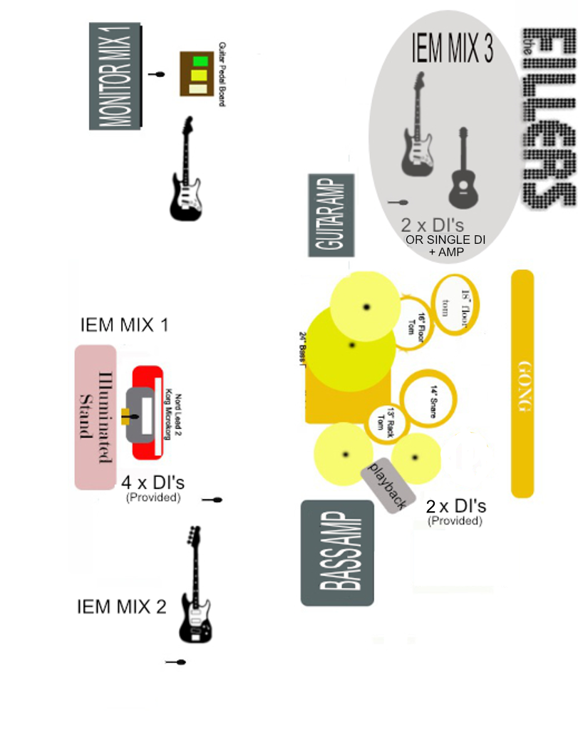

**Notes**

The singer uses 2 microphones. His main microphone will be on a straight stand and requires enough length the get all around the stage. Both the roaming mic and the wireless mic will be provided (SM58 Beta)

In-Ear Monitors is used by the singer and bassist and Second guitarist.

The Drummer requires an XLR feed into his mixing desk

Front of stage requires a minimum of 13 power points with 6 in the centre to power a light up keyboard stand.

Front Keyboards have DI’s in the setup. four XLR’s required (NO Phantom Power)

TRACKS: Computer has a DI in place. 1 XLR required (**NO Phantom Power)**

The front centre wedges need to be 2.3 m apart to leave room for the keyboard stand

With a minimum of 7 power supplies

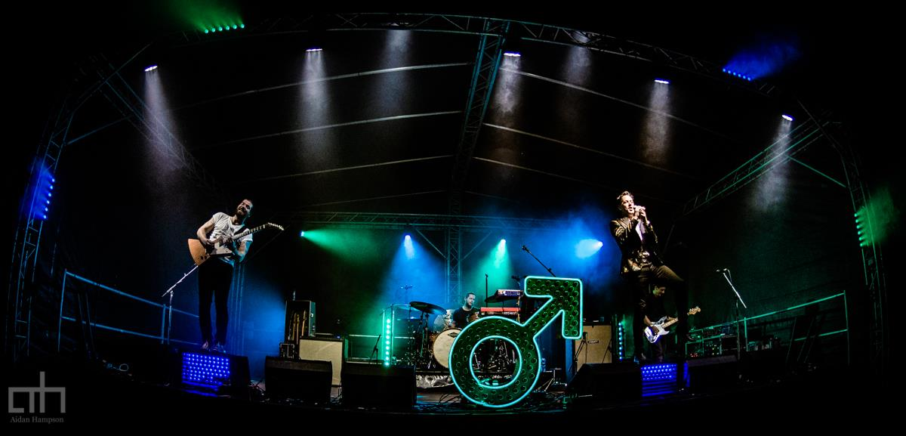

**Pyro’s / Special Effects**

The set will contain 2 confetti shots during “My Own Souls Warning” and “All These Things” All confetti is biodegradable

2 Lasers will be used and controlled via our DMX lighting system but **WILL NOT** scan the crowd (Will not be used in a daytime show)

**Fillers Monitors**

|  |  |
| --- | --- |
| **Trevor (Main Vox)**  In-Ear Monitors  Vocals roaming 10  Vocals keyboard 8  Keyboard top 8  Keyboard bottom 8  Track 7  Bass 5  Kick/snare/hi-hats 4  Main guitar 4  No bv's | **Rob/Phil   (Bassist)**  In Ear Monitors/ Wedges  Track 10  Bass 8  Bass vocals 7  Kick/snare 5  Keys 5  Main guitar 3  Lead vocals  5  No guitar vocals |
| **Luke (Drums)**  Instead of a wedge send feed straight personal mixer  Kick/Snare 10  Bass - 8  Guitar - 8  Toms - 7  Lead vocals - 6  Keyboards - 5  No bv's,  **NO TRACK!** | **Lead Dave (guitar)**  Wedge  Track 10  Guitar 7  Guitar vocal. 6  Bass. 3  Kick/snare 4  Lead vocals. 2  Front Keys 3  No bass vocals |
| **Snowy (Second Guitar)**  Second Guitar vocal 7  Second Guitar 8  Main Vocals 8  Keys 5  Track 7  Bass 5  Main Guitar 5 |  |

**Lighting Notes (SAMPLE SETLIST)**

|  |  |  |
| --- | --- | --- |
| **GENERAL: Rock show lighting. Plenty of movement. Strobing encouraged. No excessive white lighting from the front. On Confetti Shots Please light the crowd** | **Blackout after each song unless otherwise stated. Gently fade up a blue** | **Where lasers are used keep lighting low and plenty of haze.** |

|  |  |  |  |
| --- | --- | --- | --- |
| **SONG** | **Description** | **Mood/Colours** | **Cues** |
| **MOSW** | Opening song  Keep stage dark blue through the opening drone. | Blue and White | On the very first build up at the beginning of the song we fire confetti. Please light the crowd |
| **The Man** | Movement throughout | white moving spots/beams over pink/purple background |  |
| **Somebody Told Me** | Movement throughout | Loads of gold/white and strobe on the intro. Red and blue in the verses. Pink and purple in the choruses. |  |
| **Spaceman** | **LASERS!** | Blue everything on intro. White, blue & purple moving spots when full band plays. Blue one verses, Purple on choruses | Guitar spotlight in the breakdown |
| **Run For Cover** |  | Red throughout with white moving spots. As much movement as possible in the choruses/outro |  |
| **Jenny Was a Friend of Mine** | LASERS! | Loads of green and white. | search light style during the opening helicopter effect |
| **Smile Like you mean it** | Moderate movement. | blue stage with red spots throughout | Opens on front set of keys |
| **For Reasons Unknown** |  | red and white moving spots throughout | Guitar spotlight in the breakdown |
| **Shot at the Night** | **LASERS!** | Dark purple | Blackout with just lasers until the opening vocal |
| **On Top** | **LASERS!** | Spining Yellows | Lasers kick in at the end during the Pink Floyd "Time Section" |
| **Indie Rock & Roll** | Trevor on Keys for 80% of the song | All the blues | Drop the lights on the "Stay" vocal note when it ends |
| **A Dustland Fairytale** |  | dark blue stage on intro. Purple spots on middle section. Moving spots on main section. | Spot on frintman for first section if possible and keep the rest of the stage dark Spotlight on Guitar solo at the end with the rest of the stage dark |
| **Runaways** |  | Red stage with white spots throughout. Lots of movement on pre choruses/choruses | Start totally red |
| **Read My Mind** |  | Blue, white and pink varied throughout. | Blinders with the intro Kick |
| **All Theses Things That I've Done** |  | Opening section White light from behind. Purple and blue stage with gold slow moving spots throughout. Strobe on extended outro. | Confetti after the "I've got soul" breakdown. Light the crowd |
| **Encore Drone** | **LASERS!** | blackout slowly moving to very dark blue stage |  |
| **Human** | **LASERS!** | Purple and red | The middle chorus goes to the crowd so flood them |
| **When You Were Young** |  | White and gold spots/flashes with LOTS of movement on intro, choruses and outro. Slower on verses. | In the middle breakdown section full blue from behind only and fade up the front during "They say the devils water" section |
| **Mr.Brightside** | **LASERS!** | Purple/blue stage with green and white spots going mental. Strobe the shit out of the ending |  |

**Catering Requirements**

**Food and Drinks**

1. Meal buyouts or meal to be provided for 5 people
2. 1x Case of water
3. 24x Cans/bottles of Premium IPA (Brewdog/Brooklyn)
4. 1 X 1 ltr Bottle of Spiced Rum
5. 6x Cans of Coca-Cola